Teams: How to use English subtitles

◆Please enter Teams, “Okayama University CTE Faculty Development” using the following URL.
https://teams.microsoft.com/l/team/19%3a877d44202a744f4a80b08f37c07425ce%40thread.tacv2/conversations?groupId=bfc469eb-be3b-4e58-bcc4-efe603d622bc&tenantId=9e617bfd-d712-456e-ab1f-9c72c3ad7ce3

◆A meeting link will be posted on the day of the event. Click the posted link to join the meeting.

◆Please wait if there is the message, “Live event has not started yet.”
The presenter will begin at 14:00.

◆When the live event begins, you will move your cursor to the lower right hand side of the screen to see these buttons.

Settings
Captions/Subtitles

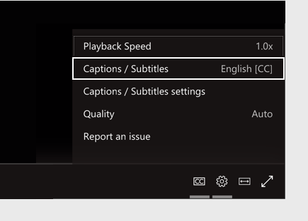
◆Click “Settings” to see the following video controls.

◆Select “Captions/ Subtitles” on and choose the language “English.”

